**DSA PRACTICE**

November 18 , 2024

**1.Bubble Sort**

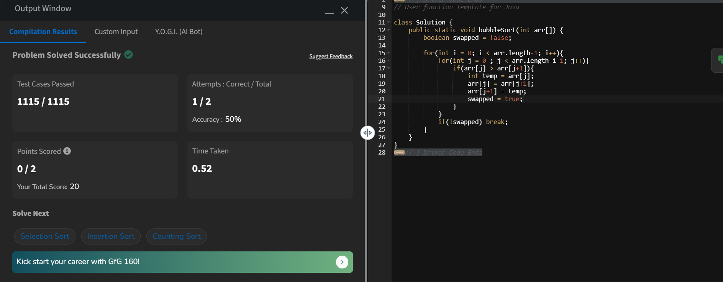

Time Complexity : O(N ^ 2)

Space Complexity : O(1)

**2.**